|  |
| --- |
| MAMUN’S GAME STUDIO |
| **FIGHT FOR COLORS** |
| A RETRO SHOOTER GAME |
| Version #01  All work Copyright © 2012 by MAMUN’S GAME STUDIO.  All rights reserved. |
| **MD MAMUNUR RAHMAN** |
|  |



|  |
| --- |
| **October 27th, 2016** |

**Table of Contents**

Version History 4

Game Overview 5

Game Play Mechanics 5

Camera 5

Controls 5

Interface Sketch 5

Menu and Screen Descriptions 6

Menu Scene: 6

Game Scene: 7

Characters 7

Enemies 8

Items 8

Scoring 8

Sound Index 8

Story Index 9

Art / Multimedia Index 9

Design Notes 9

Future Features 10

# Version History

All of the game version histories are preserved in GitHub. GitHub link of the game is given below.

GitHub Link: <https://github.com/300872772/COMP305-F2016-Assignment1>

# Game Overview

‘Fight For Colors’ is a simple retro side-scrolling shooter game. The player’s space ship is limited to the bottom portion of the screen. The background colourful world graphic scrolls in top-down direction. The player must avoid killer Relic and grab power Relic while moves through the color world.

# Game Play Mechanics

This game can be played on any web browser and player space ship is controlled by mouse or left to right arrow keys. There is a start button at the beginning and a restart button at ends. Score and lives of the player are shown on the top of the game screen.

# Camera

The camera for this game uses an orthographic projection from a top-down (birds eye) view.

# Controls

The control of this game is with the mouse only. The mouse allows the player to move left to right across the bottom of the screen.

# Interface Sketch

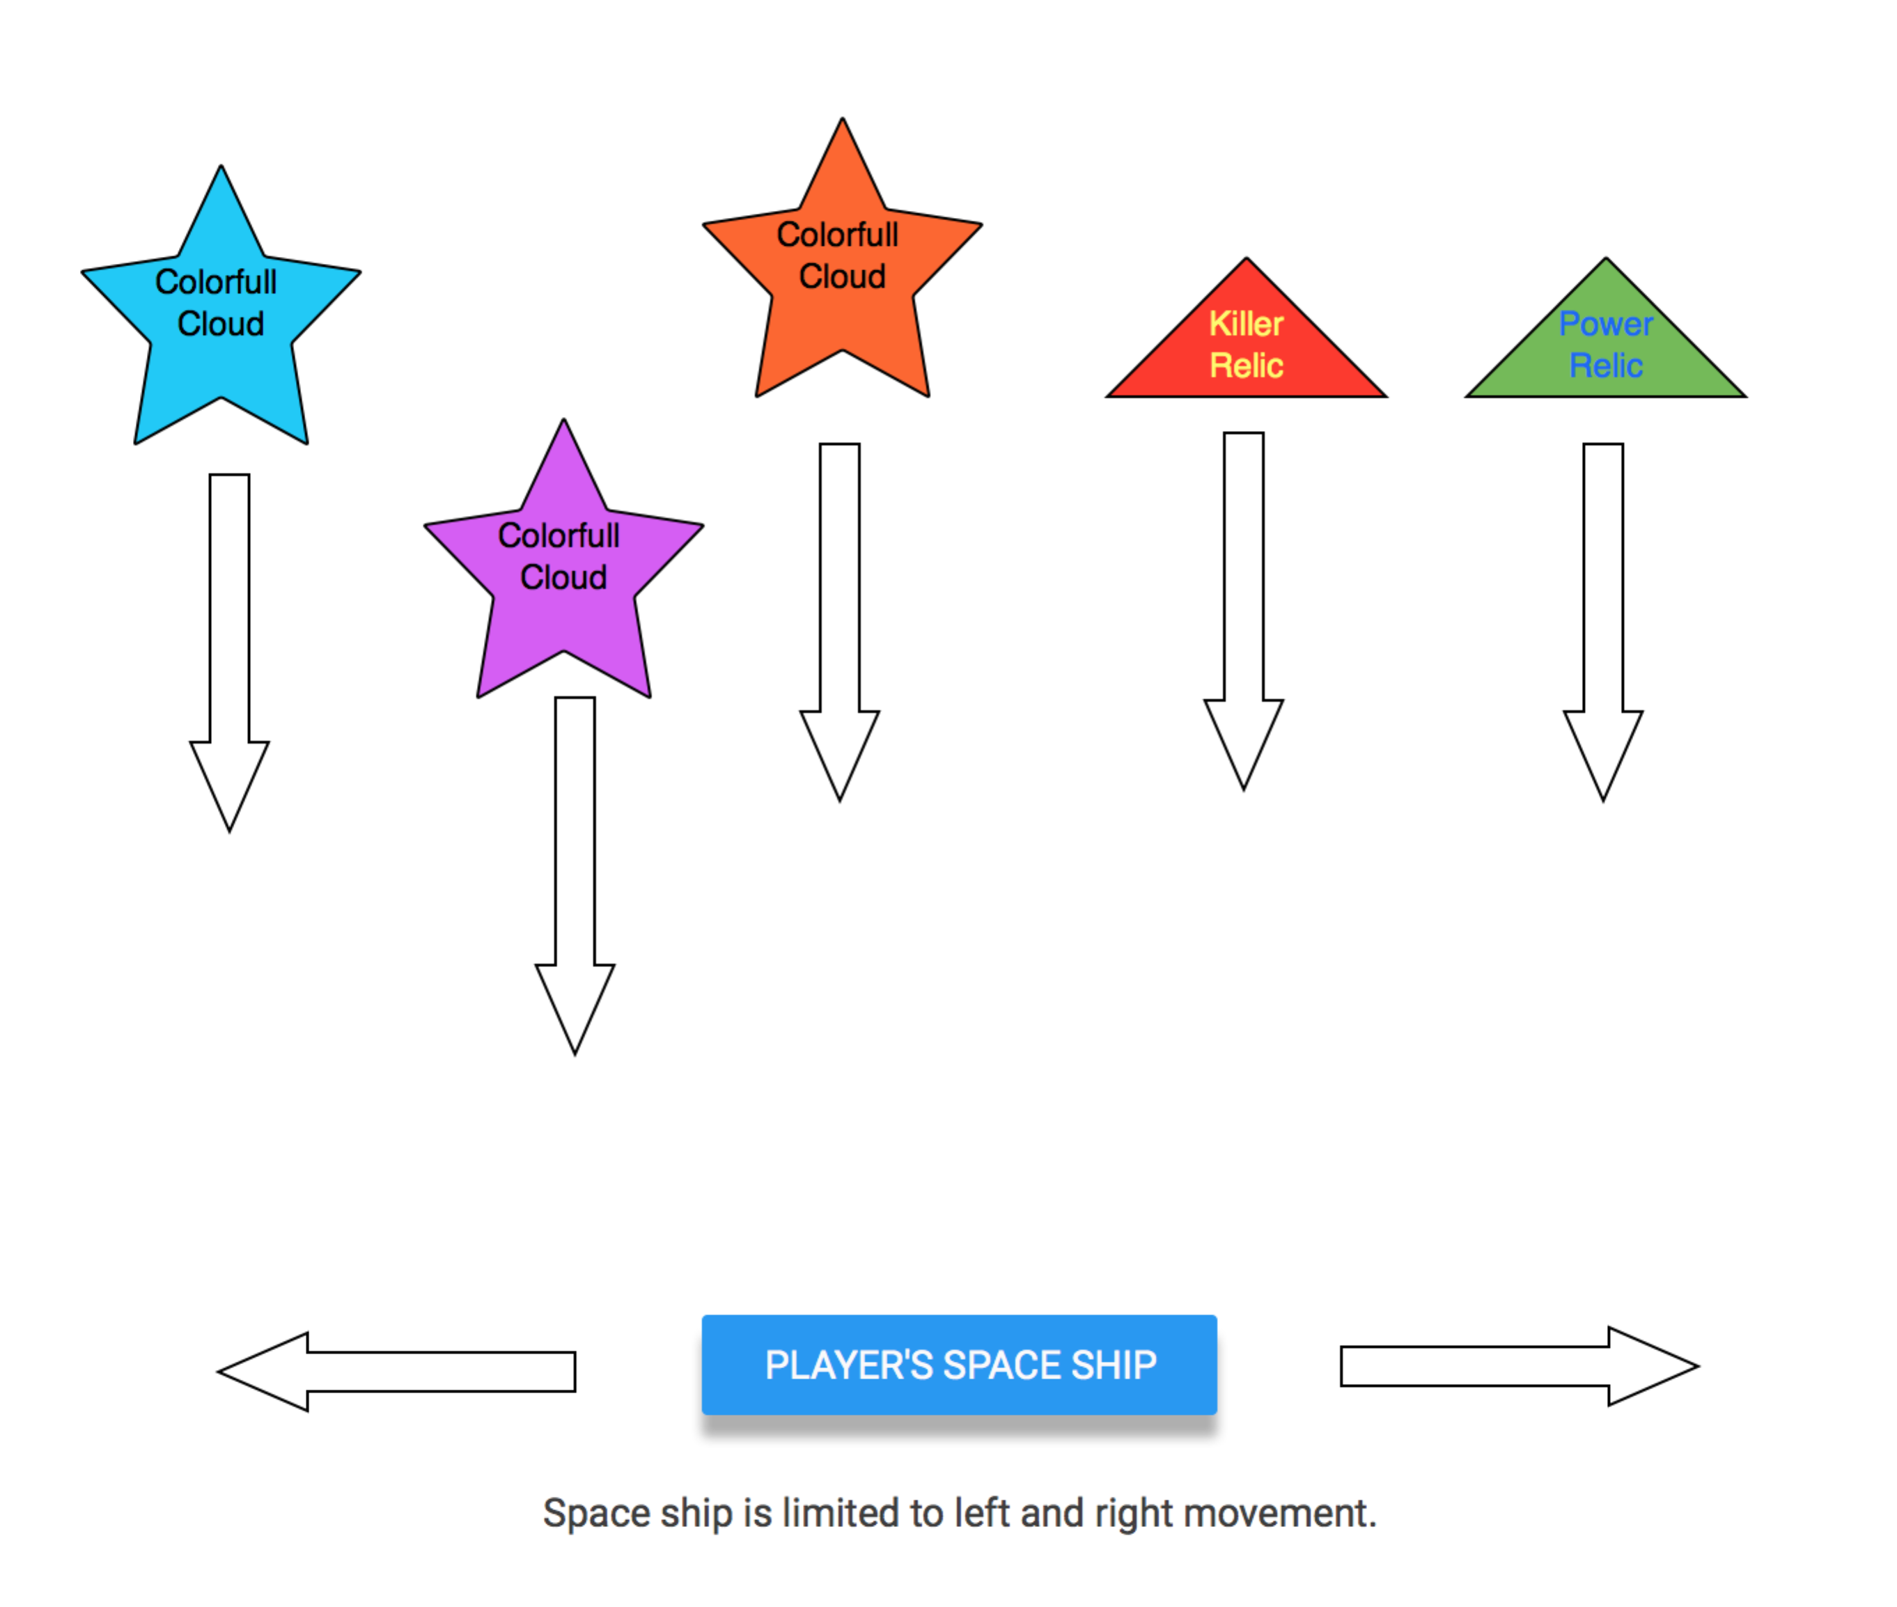

# Menu and Screen Descriptions

**There are two scenes of these game, which are Menu, and Game. Menu scene holds the screen at starting and releases it to game scene once game starts.**

## Menu Scene:

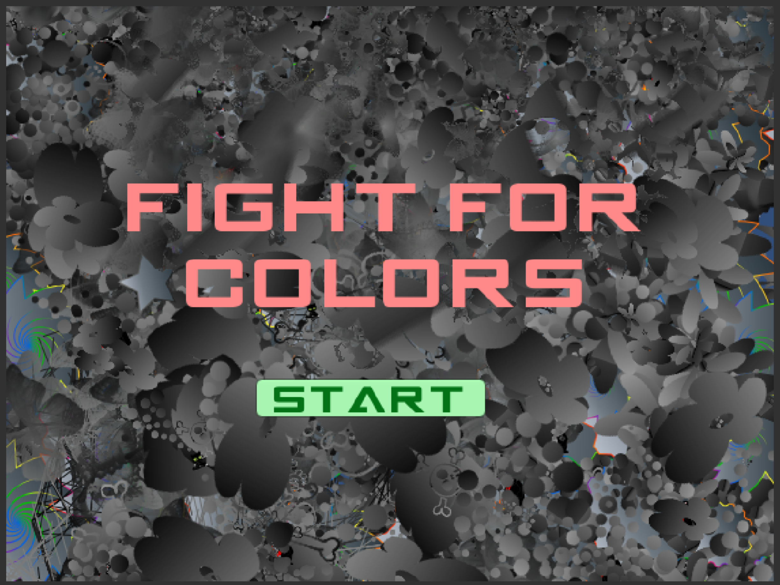

## Game Scene:

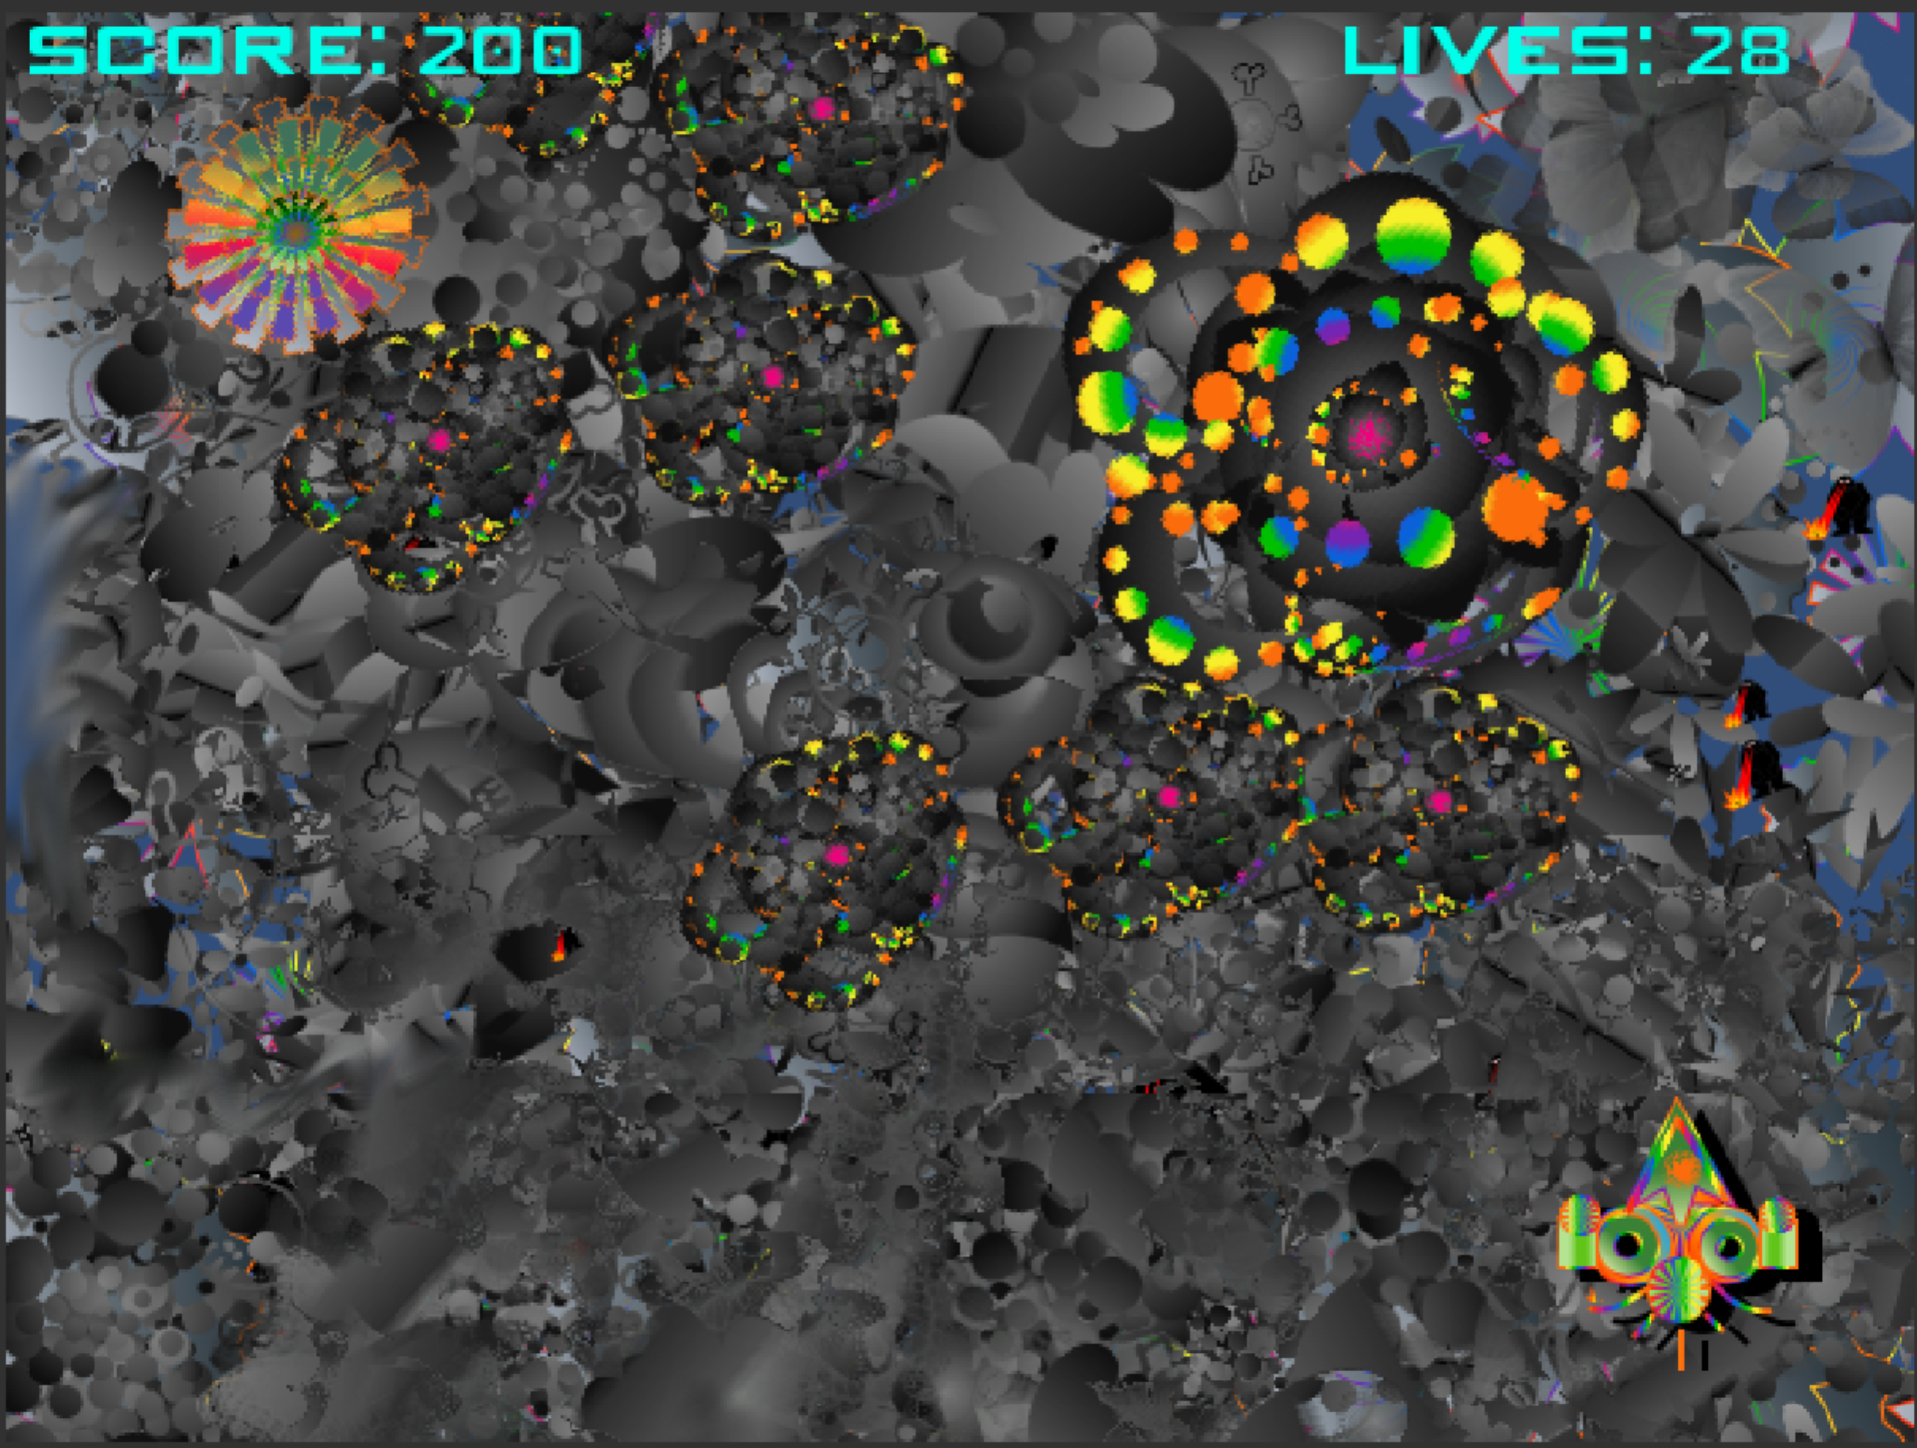

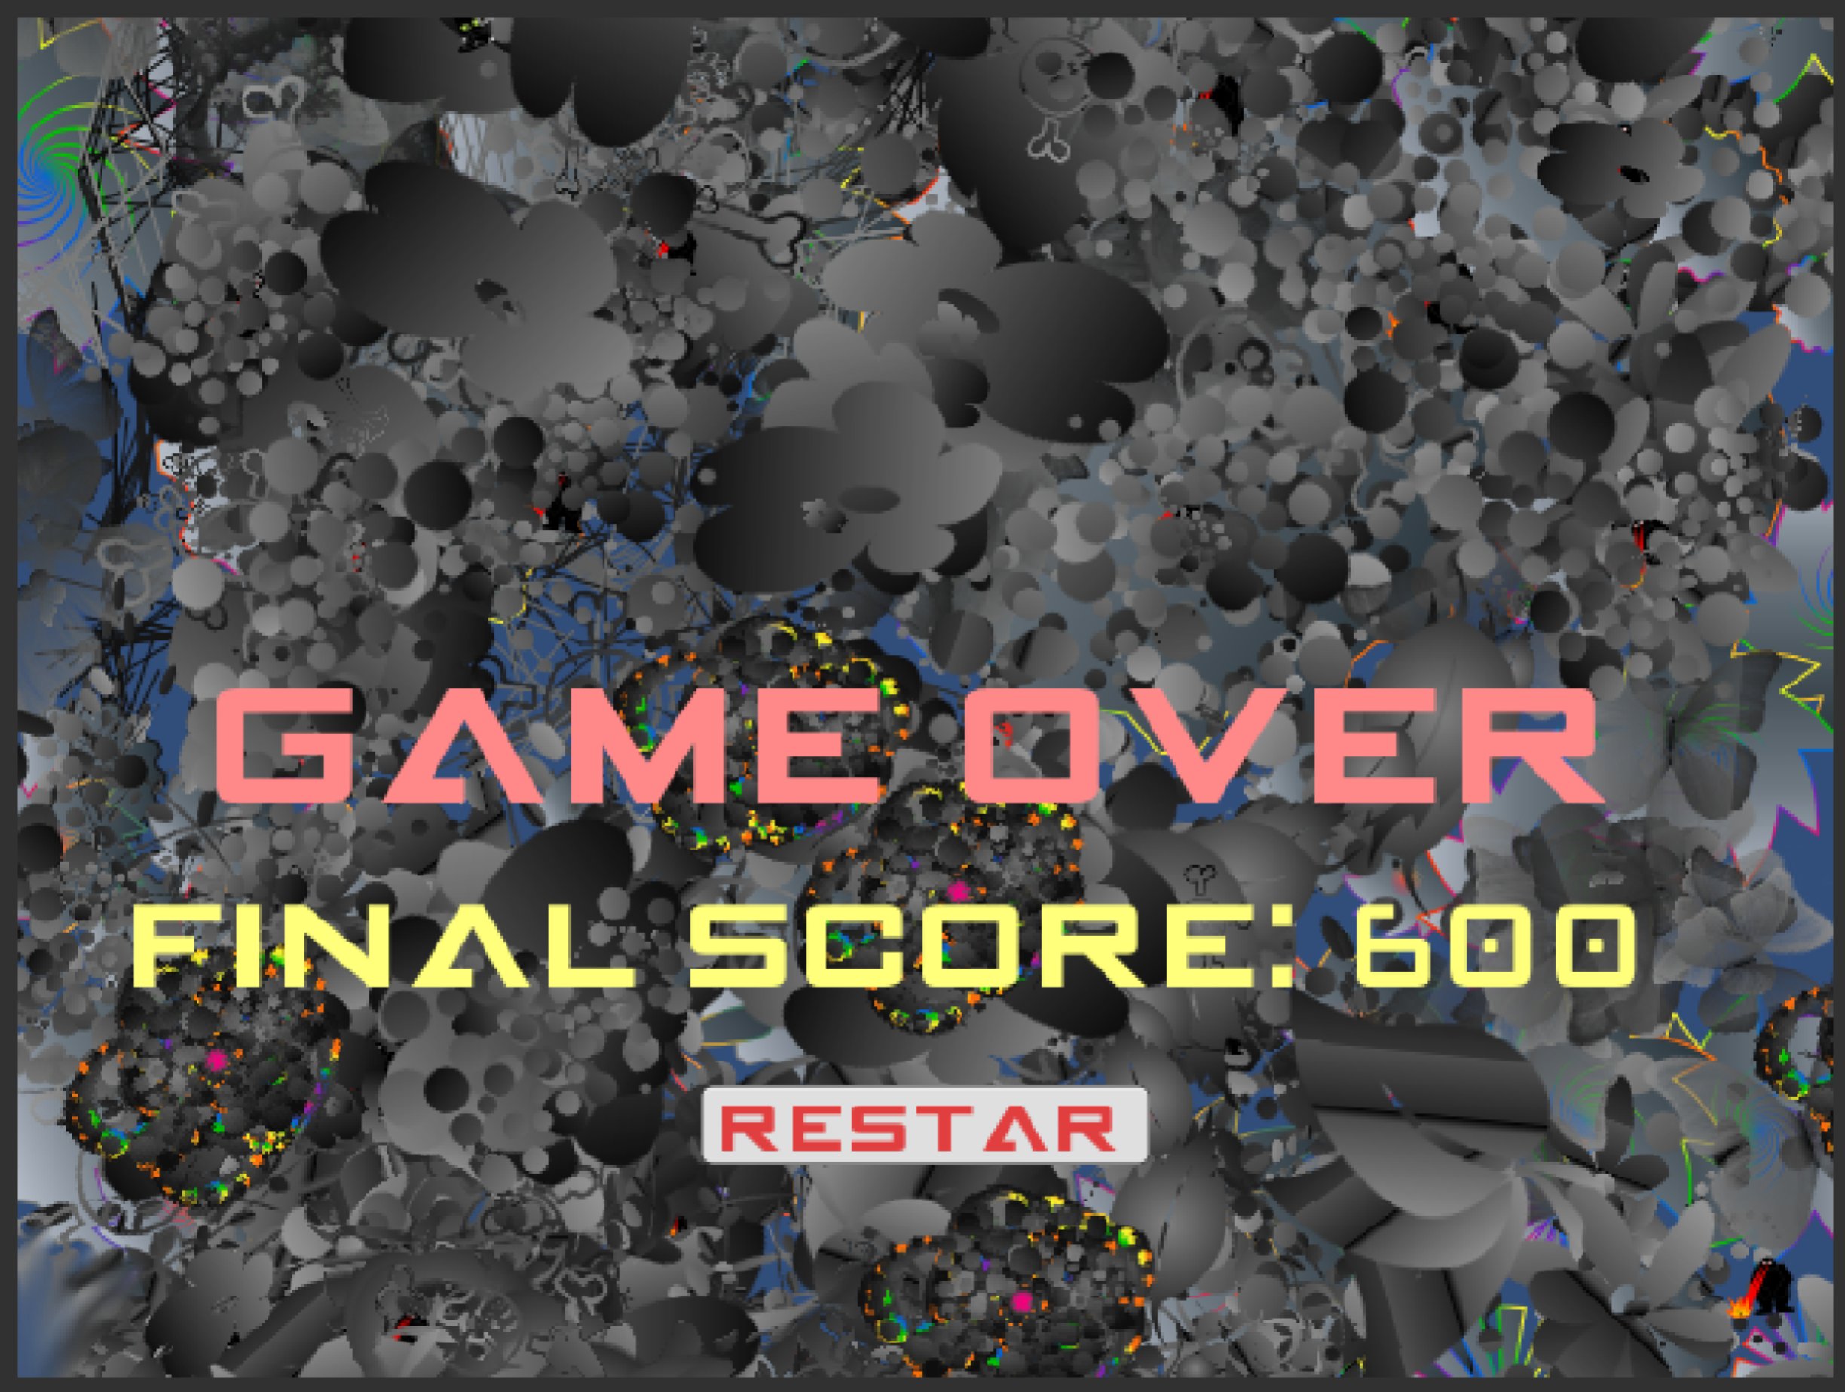

# Characters

The player’s avatar is a simple colourful space ship that seems to fly over a scrolling colourful world. The player’s movement is limited (right to left only) to increase the challenge level of the game.

# Enemies

The enemies of this game are killer Relics that the player must avoid. Besides, there is enemy space ship to kill players. We will add animated lightening if time allows.

# Items

The player’s main pickup is power Relic and killing enemy ships to gain points.

# Scoring

The player score points when grab power Relic and kills enemy space ship. Each power Relic gives 100 points and killing each enemy space ship gives 50 points. There is no point for destroying relic and only gives free space to move. The player starts with 200 lives. Big, medium and small killer Relic grab 1,2 and 3 lives respectively and 3 enemy shooting hits makes one life down.

# Sound Index

There are 6 types of audio sounds and the main game sound is composed by me using GarageBand software.

|  |  |
| --- | --- |
| Audio File Name | Details |
| MainSound.wav | **This sound continues all through the game.** |
| PowerUp.wav | **This sound starts when Avater get power Relic** |
| Hurt.wav | **This sound starts when Avater hits killer Relic** |
| LaserShoot.wav | **Laser shoot sound start when there is laser shoot.** |
| Explosion.wav | **Explosion sound works when killer relic and enemies dies.** |
| endSound.wav | **This sound starts when game comes to an end.** |

# Story Index

A planet inside colourful Andromeda galaxy has been covered by black power and Avatar has got mission to fight against black power to rescue colourful world. This is the story of Fight for Colors, colors of life.

# Art / Multimedia Index

We drew all characters except enemy ship.

* **Avatar** needs to avoid killer relic and have only moving option in right and left.
* There are three types of **Killer Relic** configured in different shape and hold different killing power.
* There are two sizes of **Power Relic**, which gives point to the player.
* **Killer Relic** act as enemy and also there is different **Enemy Ship**, which has shooting power.

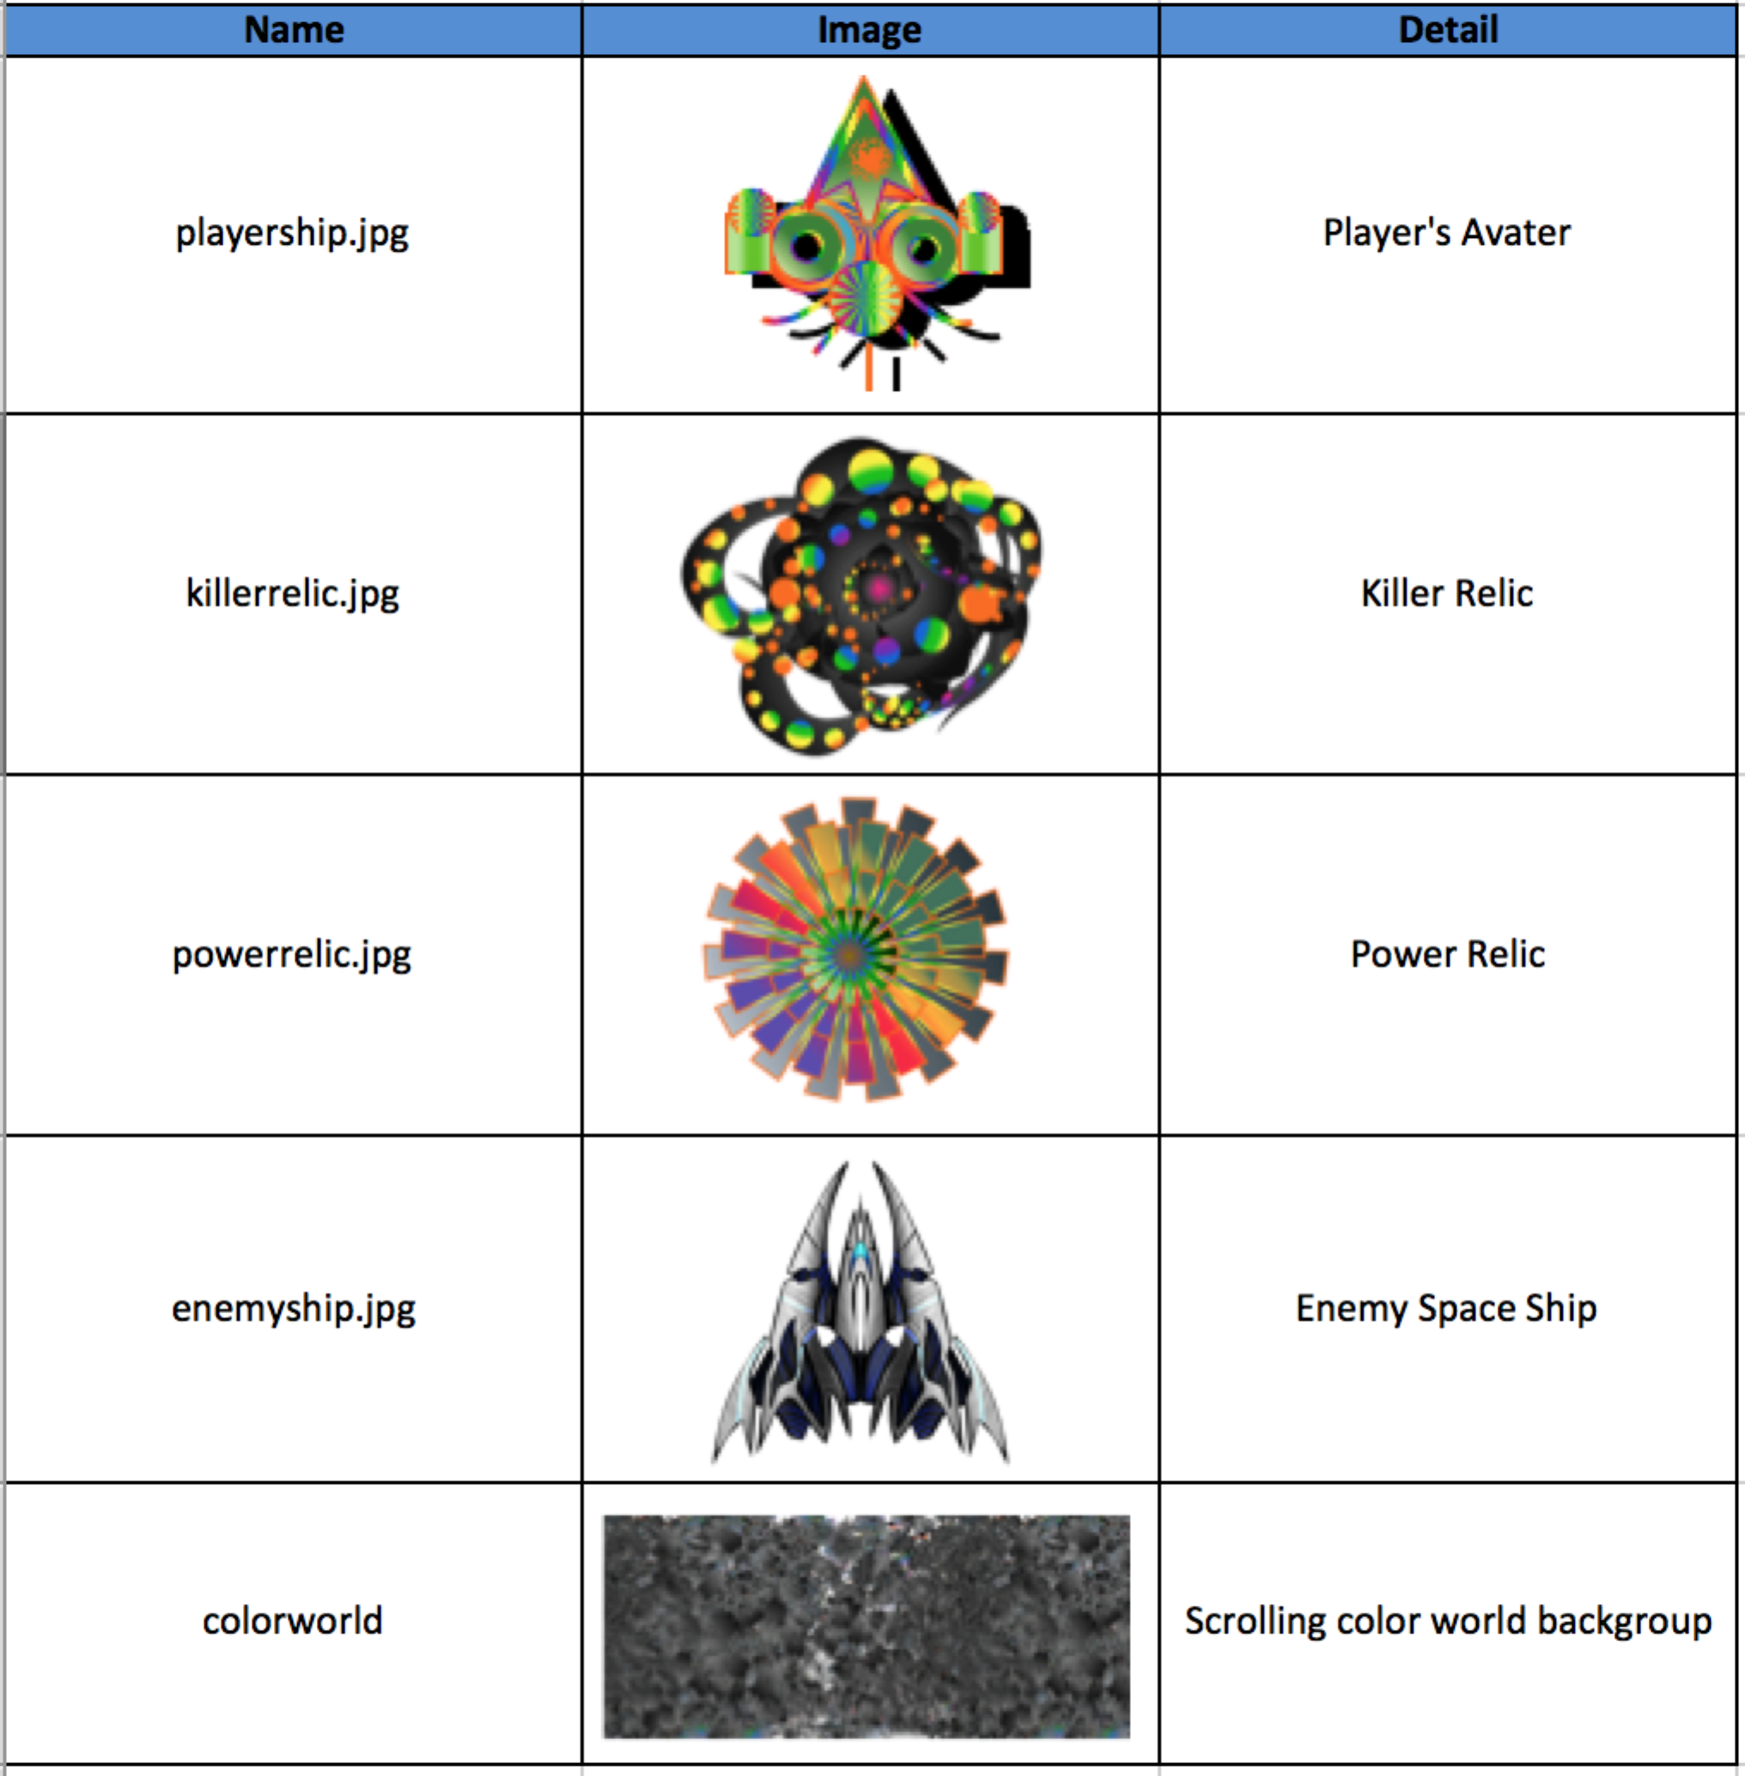

# Design Notes

All the graphic designs were done by the online software ’ <https://sketch.io/sketchpad/>’ and GIMP.

# Future Features

In future we will include different game levels.